CURRICULUM VITAE

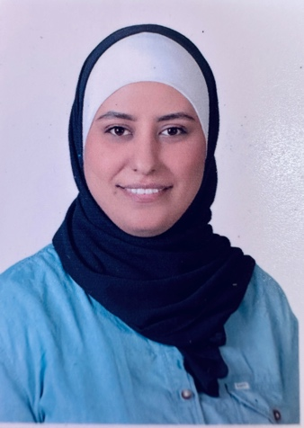
Marya Mustafa Abuzaid
Department Of Multimedia Technology
Al-Zaytoonah University of Jordan, Amman, Jordan,
E-mail: marya.abuzaid@zuj.edu.jo
Homepage:

- Personal Data

Date of Birth: 19/4/1995
Nationality: Jordanian

- Education

- M.Sc. (Instructional Multimedia) 2020, University of Science Malaysia, Penang, Malaysia.

- B.Sc. (Multimedia combined with Islamic science) 2018, Islamic Science University of Malaysia, NS, Malaysia.

- Research Interests

- AI in Multimedia
- Interactive Multimedia Design
- Multimedia Learning and Education
- Accessibility in Multimedia
- Emotion and Perception in Multimedia

- Teaching Experience
- Undergraduate Courses

- Web Page Design and Content Management Systems
- Selected Topics in Multimedia
- Scenario, character design and backgrounds
- Principles of 2D & 3D Design
- Human Engineering
- Photography & Digital Processing
- Principles of multimedia design

